FORMBY VILLAGE BOWLS CLUB

CLUB HANDBOOK

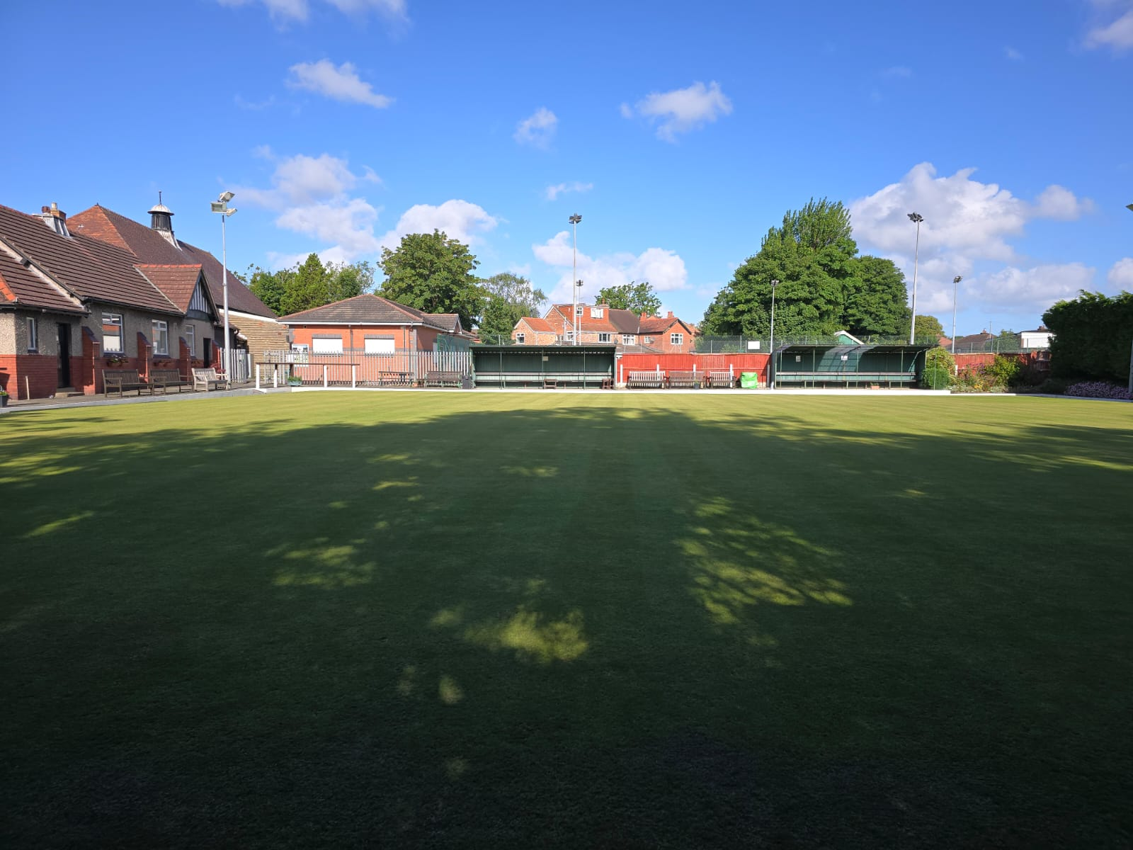

March 2026

Welcome to Formby Village Bowls Club. This Handbook is designed to provide as much information as we can about the club and our organization.

This document is to be read in conjunction with the Club Rules

Enquiry, contact and membership application forms are available on the website.

Further Information can be found on our website https://www.formbyvillagebowls.com

The Club Address

Formby Village Bowls Club
Behind Church Hall
Rosemary Lane
Formby
Merseyside
L37 3HJ

Parking
Please note there is an automatic parking system called “Parking Eye” in operation within the church grounds. Parking is only permitted in the church car park when members or visitors to the club are using the Sports Club facilities.
If you have parked in the church car park you must enter your registration in the “parking eye” system.
Registration terminals are located in the parish hall, the bowls pavilion, the tennis club and the snooker room.
Parking is FREE but Non Registered Vehicles will attract a fine of £100
Any of our members would be pleased to assist you with registration.
There is NO PARKING from 8.00 am to 1.00 pm on a Sunday without exception, or during church events such as weddings or funerals. Parking restrictions as required by the church must be obeyed
Subscriptions
Members joining any of the sports clubs are required to pay a membership fee to the Sports Club to maintain the overall operating costs of the club and a fee to the relevant section. Note that there is only one payment to the Sports Club required and you can join as many sections as you like just by paying the additional fee to that section. Subscriptions are due by End March each year.

HANDBOOK CONTENTS

- Our Mission Statement
- The Club Committee
- Teams, Captains and Fixtures
- Frequently Asked Questions
  - How do I get a key for the clubhouse?
  - How do I get into a league team?
  - What are internal competitions?
  - How does the handicap system work?
  - Can I get help to improve my game?
  - How can I help with the maintenance of the Club?
  - How do I join the Formby Village Bowling Club’s Facebook Community?
  - How do I find out about the other sections in Formby Village Sports Club?
- Crown Green Bowls Etiquette
- Code of Conduct
- Clubhouse Organisation and Key Policy
- Safeguarding Policy

- Health & Safety Policy

Our Mission Statement

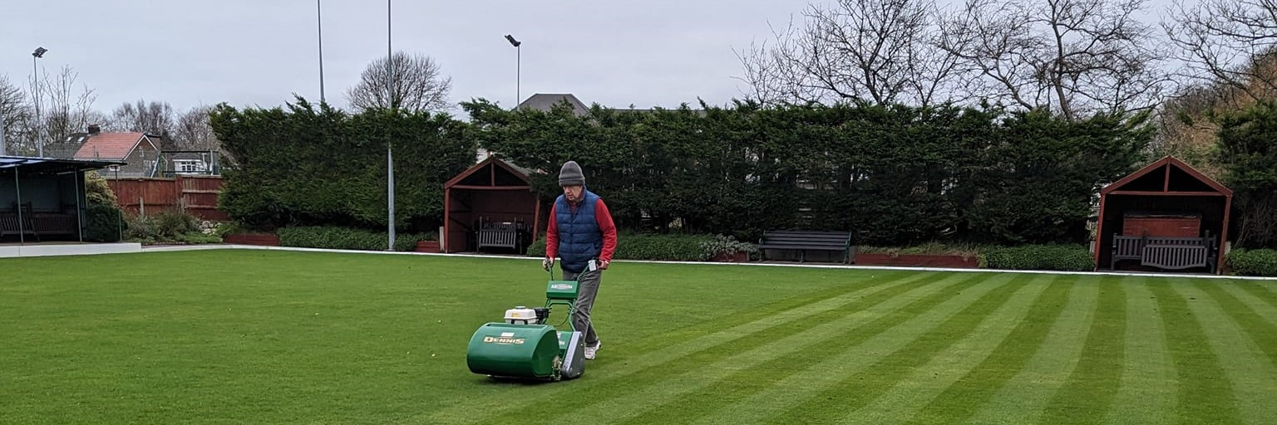

With well over a century of continuous bowling activity, Formby Village Bowling Club still adheres to the founding principle established by the Reverend John Brooke Richardson, that the club “should be open to all in Formby irrespective of religion or class”. This founding principle has been expanded over the years to include the words “open to all without discrimination”. Based on this principle our overall aim is to foster the game of Crown Green Bowls.
We are committed to providing a safe environment in which players of all ages can enjoy a range of social and competitive activities.
The day to day running of the club is in the capable hands of our club committee. They work closely together to ensure the Green and the club house are maintained to a very high standard. Our Green is the envy of many visitors.
We observe the protocols and procedures defined by the British Crown Green Bowling Association and members can be assured that all legal, welfare and safeguarding requirements are fully complied with.
Social bowls, where you play simply for the fun of it, takes place most weekday afternoons from April through to October. The ladies have the sole use of the Green on Tuesday and Thursday afternoons and the men on Wednesday and Friday afternoons. There are fun competitions on some Saturdays and also organised visits to other clubs.
For those who are more competitively minded there are currently 9 teams playing in four different local leagues throughout Formby, Southport, Maghull and Orkskirk. Standards vary so there will probably be a league team that satisfies your ambitions. There are also club competitions open to ladies, men and some mixed events.
We are always ready to welcome new members of any standard, from beginners to the highly experienced. Beginners will find willing helpers to guide them through the rules and techniques and we now have our own British Crown Green Bowling Association qualified coaches.

Club Committee
The Club Committee is comprised of members who volunteer their time to serve for 12 months and are elected at the Annual General Meeting in January each year. Committee members may offer to serve for many years but are subject to re-election each year. Some members of the committee take on particular responsibilities for activities within the club as detailed below.
The club committee for 2026 is as follows
Club President | Peter Dunne
Committee Chair | Jeanette Heague
Secretary | Gary Wallis
Treasurer | Geoff Ruddock
Safeguarding Officer | Jeanette Heague
Membership Secretary | Vacant
Estates Management / Website | Steve Jones
Estates Management | Rick Welch
Green Management | Vacant
Member | Judy Muchall
Member | Gwen Parkinson
Member | Steve Powell
Member | Paul Gibbons
Would all members please contact a committee member if they become aware of any significant life events within the membership (births, deaths, marriages etc.) so that we can take any appropriate actions, thank you.
The committee endorse the view that all tasks are a shared responsibility of all members, namely
- The general maintenance of the estate.
Throughout the season working parties are held on the first Tuesday morning of each month to maintain the Green, the Clubhouse and the surrounding infrastructure of the club. If you can spare some time to come along help please do. We will be working between 10.30am and 12.30pm.
- Helping run the internal competitions.
Running an internal competition requires a team of three members to promote the competition, organise the draw and provide professional oversight during the day of the competition.
- Introducing and welcoming new members.
New members do need help in understanding the way the club operates and how to become more closely involved in both social and competitive bowling.

Teams, Captains & Fixtures

Southport Vets
Monday Afternoons

1. Vets A - Graham Redfern Formby Village A
2. Vets B - Ray Wheatley Formby Village B
Fixtures & Results - Link to external website https://www.bowlsresultstwo.co.uk/southportvets/index.php?if=0

Maghull Evening League
Monday Evenings

3. A Team – Joan Clarkson Formby Village
Fixtures & Results - Link to external website
https://www.cgleague.co.uk/maghull/

Ormskirk and District League
Tuesday Evenings

4. A Team - Garry Finch Formby Village A
5. B Team - Gary Wallis Formby Village B
Fixtures & Results - Link to external website
https://bowlsnet.uk/Ormskirk

Formby and District Bowling League
Wednesday Evenings

6. A Team - Paul Gibbons Formby Village A
7. B Team - Dave Kirkby Formby Village B
Fixtures & Results - Link to external website
https://www.cgleague.co.uk/formby/

Southport Parks League
Thursday Evenings

8. A Team – Paul Banks Formby Village A
9. B Team - Keith Jacques Formby Village B
Fixtures & Results - Link to external website
https://www.bowlsresultstwo.co.uk/southportparks/index.php?if=0

Frequently Asked Questions
How do I get a key for the clubhouse?
A key to gain access to the clubhouse is available to members from the Treasurer (Geoff Ruddock) for a small usage fee payable annually. See below for full details of our KEY POLICY.
How do I get into a league team?
There is no written policy about how new members get into a team. A good place to start is to enter our internal competitions and gain experience of competitive bowling. A second option is to attend ‘social bowling’ sessions, you will very quickly be noticed by team captains! The third option is to approach team captains directly. We have “A” and “B” teams in four different leagues and opportunities regularly arise.
What are internal competitions?
Details of the dates and style of competition are posted on our Website, our Facebook pages and the notice boards at the clubhouse. Entry forms are posted on the clubhouse noticeboards – you simply write your name and leave the rest to the competition organisers. One day knockout format competitions will include a consolation tournament (Plate), ensuring that all first round losers will play at least two games. This does not apply to the mens Challenge Cup or competitions that run through the season. All competitions are subject to FVBC and BCGBA rules and regulations.
Can I get help to improve my game?
Yes, we have a British Crown Green Association qualified coaches available. Book a session for free and the coach will help instill the disciplines needed to become a competent bowler. Ask any committee member for their contact details.
How can I help with the maintenance of the Club?
The green is maintained and cut regularly by a team of volunteers (known as the “Cutting Crew”) working under the guidance of our committee and the Greenkeeping team. We are always grateful for any help offered by members to join the cutting crew or to offer any other help. Estate management is overseen by other members of the committee and working parties are held on the first Tuesday of each month to perform routine tasks around the club such as edging the green, painting, repairing infrastructure, equipment maintenance, general cleaning etc. We now look after our sprinkler system ourselves and have our own borehole to source ground water. There are also administration functions that you may be able to assist with. If you have a skill set that you think would benefit the club please speak to any committee member and offer your services.
We would like to think that all able bodied members will make a physical contribution to help maintain the estate.
Each month the committee member responsible for Estate Management will post a list of the working party tasks to be performed. You simply turn up and get stuck in.
How do I join the Formby Village Bowling Club Facebook Community?
To join our Facebook Community, you first need to join Facebook. Once you have joined you can then ask to join our Facebook Community by sending an email or an existing member can invite you to join.
We all have equal rights to post photographs, articles, news items etc. – the only editorial policy we maintain is that the ‘post’ should be directly connected with Formby Village Bowling Club. Our Facebook Community is a ‘closed’ community and can only be viewed by its members.
How do I find out about the other sections of Formby Village Sports Club?
The Bowls section is just one part of the Formby Village Sports Club.
There are also sections for Tennis, Padel, Table Tennis and Snooker
Formby Village Sports Club is a Limited Company that carries the legal responsibilities for all of the sports sections operating under its umbrella. The Sports club has a small committee that oversees the running of the club and assists each sub section as required to run their clubs. All clubs are located at the Trinity Church site in Rosemary Lane Formby.
There is no physical “sports club” as such, it exists to allow the various sports clubs to operate without the need for each to have their own Insurances and Energy Bills for example. Each section has its own committee to run and organize their respective sports, Tennis, Padel, Bowls, Snooker and Table Tennis. They can call on the Sports Club committee for assistance whenever needed.
Members joining any of the clubs are required to pay a membership fee to the Sports Club to maintain the overall operating costs of the club and a fee to the relevant section. Note that there is only one payment to the sports club required and you can join as many sections as you like just by paying the additional fee to that section. Some sections will offer discounts or introduction packages if you wish to “try before you buy”.
If you would like further information of our club please take a look at our Facebook pages
The best sources of information are our websites www.formbyvillagesports.com or www.formbyvillagebowls.com
Or you can contact us by e-mail at
membership@formbysportsclub.com
membership@formbyvillagebowls.com

Crown Green Bowls Etiquette
The following guide takes the player through the cycle of a typical game following a recognized pattern.
At Commencement of Game
Players should introduce themselves with a handshake. If the event is refereed, you may find that the Referee makes the introductions. Find your markers and make sure they know who you are. Markers should make themselves known to each other and both players and markers should be aware of the score required to win the game. The footer should be placed within three meters either side of the ‘Entrance to the Green’ and one metre from the edge. The ‘Entrance’ should be marked with an appropriate sign and this should be in place before the visiting team commence practice. The foot corresponding to the bowling arm must be placed on the footer. If you are the player bowling the jack, you should show your opponent the jack and allow your opponent the opportunity to determine which bias is being used.
Game/End in Progress
Allow your opponent a view of the line taken by the jack. Bowl only when the previous jack or bowl has stopped running. Once bowled, no attempt should be made to affect the running of any bowl. If you wish to follow up your bowl you must do so without obstructing the view of your opponent.
On your return to the footer, you must again keep clear of the ‘jack line’ to avoid distracting your opponent who is about to bowl. If you require advice on the lie of the bowls, the onus is on you to find out for yourself. The Referee may give an opinion if so willing and in the vicinity but it is not in the Referee’s remit to do so. Non-playing players and spectators are allowed to give advice but must do so from off the playing surface. If advice is asked for then this should be asked for by the player who has command of the footer i.e. the player who is about to bowl. Temptation to shout ‘who’s on?’ by the player whose bowl has just stopped, should be resisted. This will only cause unwanted and often unlawful interference. If your opponent is about to bowl and wants to know who is on, your opponent will ask, if not, respect your opponent’s choice and wait until you regain the footer.
Remember that the players playing, the Referee and the Measurers (when required) are the only ones allowed on the Green.
The player who arrives at the ‘head’ first should not obstruct the opponent’s view or stand directly behind the jack. If you intend to strike at any time during an end, then you must warn your opponent and take every precaution before striking to prevent injury to any other party located within the ‘danger area’. Remember that safety is your responsibility. The Referee does not need to know of your intention to strike unless the Referee is also within such an area.
Be aware of other games in progress at the same time as yours. Move briskly and tread carefully across the Green. If you have to leave the Green for any reason during a game then you must inform your opponent and obtain permission from the Referee. In this instance ‘leaving the Green’, means out of sight of the Green.
Conclusion of End
Do not move the jack or any bowls claimed to count before agreeing with your opponent. If measures are required then stand away and let the Referee and/or measurers get on with it. Signal your score to the markers only when conceded by your opponent.
Succeeding End
To start the next end the leader must place the footer within one metre of the spot where the jack lay at the previous end but not within one meter of the edge of the Green. If the leader fails to set a mark for any reason, then the opponent must play from the footer position chosen by the original leader.
End of Game
Accept defeat gracefully and always offer congratulations to the winner at the end of the game.
In General
Have respect for your opponent and refrain from any adverse comments during the game. Have respect for the Referee and abide by the Referee’s decisions. Remember that it is not the Referee’s job to give decisions on the lie of the bowls. Any lack of confidence directed towards the Referee because of an apparent reluctance to give opinions/decisions is therefore out of place. The Referee is not there to be at the beck and call of the players. Remember also that mobile phones and pagers in active mode are not allowed on the Green and that smoking is not allowed whilst participating on the Green.
Sportsmanship  Etiquette also embodies sportsmanship. For example, if a running bowl is impeded after going beyond the head or is so wayward it runs into another head, the Laws of the Game allow such a bowl to be replayed. But is this taking advantage where none was intended? On this and other similar occasions sportsmanship should prevail and players forgo the right to replay such a bowl. | 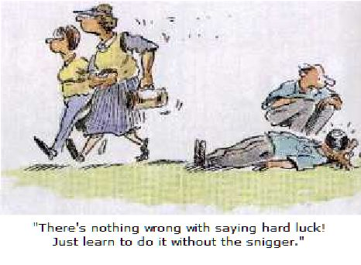

Code of Conduct – Formby Village Bowling Club
Members are expected to conduct themselves in ways which display the following:-
1. Good standards of behavior both on and off the green.
2. A sporting approach to team colleagues, opponents, officials and spectators.
3. Behavior befitting good ambassadors for the club.
Members must not:-
1. Use abusive or threatening behavior towards others.
2. Harass, bully or abuse other persons, physically or verbally
3. Show any form of discrimination against other persons motivated by gender, marital status, sexual orientation, race, colour, nationality, ethnic origin, disability, age, occupation, religion or political opinion.
Any member whose conduct is considered to be contrary to the best interests and welfare of the Club, will be requested to attend before the Committee or its Representatives to give an explanation of such conduct. If such a member fails to attend, or if such explanation in the opinion of the Committee be unsatisfactory, the Committee shall have the power to suspend such a member from the Club.

The notice of suspension shall be given in writing.

Clubhouse Organisation and Key Policy

Locks
Locks fitted to the Bowls Pavilion, Tool Shed, and Men’s Toilet comply with BS3621, as specified to Security Level 1 in the Insurance Policy documentation agreed by the Formby Village Sports Club Main Committee.

Lists of Key Holders
A comprehensive list of all members of the Bowls Club holding keys to the Pavilion and Lockers is kept on the Bowls Club database by the treasurer.

Ownership
All Club Keys will remain the property of the Bowls Club. If they are lost, stolen, or mislaid, replacements will be provided by the Club, but a charge will normally be made. Copying of keys is strictly forbidden. Any member ignoring this ban could be liable to misconduct procedure.

Bowls Pavilion
Keys are available to all Full Members of the Bowls Club for a small charge. This is non- refundable.

Lockers
There are a limited number of lockers provided within the Pavilion available for a small rental Fee (currently £5 per annum).

Gents Toilet
The Gents toilet is located externally on the Beaufort Hall adjacent to the Bowls Pavilion. Access to this toilet is by a key permanently kept in an accessible position inside the Bowls Pavilion. Please ensure the key is returned to its correct location after use.

Ladies Toilet
The Ladies toilet is located within the Beaufort Hall. Access is via the door to the kitchen of the Beaufort Hall. A kitchen door key to the Beauford Hall is kept in an accessible position inside the Bowls Pavilion. Please ensure the key is returned to its correct location after use.

Captain's Keys
All team Captains are provided with a Pavilion Key, toilet key, and locker key.

Cleaner's Keys
The Cleaner is provided with a Pavilion Key, a key to the Beaufort Hall and a key to the Gents Toilet.

Tool Shed
Keys to the tool shed locks are issued to the Men’s Committee members responsible for maintenance work etc. Spare keys are permanently kept in an accessible position inside the pavilion for general use.

Safeguarding Policy

FVSC accept our obligation to exercise a duty of care and to safeguard the welfare of everyone participating in the Club’s activities.

We are committed to do this by acknowledging that our members
- welfare is paramount
- have the right to protection from bullying or abuse irrespective of age, gender, ability, race, cultural background, religious beliefs or sexual identity,
- have the right to be safe,
- have the right to be treated with respect and dignity

We will ensure that
- all allegations of bullying or abuse are dealt with under the policy guidelines
- the response to them is swift and appropriate
- such concerns or allegations will be shared with the Safeguarding Officer (SO) who will contact the appropriate authority if necessary.
- confidentiality will be maintained for all concerned
- the effectiveness of our policy is reviewed regularly
- a responsible person shall be appointed annually as Safeguarding Officer to whom members can address any concerns

The Safeguarding Officer is responsible for
- monitoring and recording concerns
- ensuring issues are dealt with appropriately and under the policy guidelines
- making referrals to the appropriate authority without delay
- liaising with other agencies
- arranging safeguarding training when appropriate
- arranging emergency first aid training when appropriate
- checking that the coach has appropriate coaching certificate/license to coach
- arranging with other committee members for the safe recruiting of any volunteers/coaches to work with juniors

Welfare, Health and Safety
Who to contact

The club has nominated committee members who look after the Welfare, Health and Safety and Safeguarding of members.

For Health and Safety, the committee chair and the estate manager visit the club and green annually before the opening of the season and undertake a risk assessment (a legal requirement)* of the site for its safety according to given criteria. The criteria is matched to suit the requirements of the BCGBA recommendations for H&S and our own insurance requirements.

As a brief overview, the HASAWA 1974 requires that workplaces provide:
- Adequate training of staff to ensure health and safety procedures are understood and adhered to.
- Adequate welfare provisions for staff at work.
- A safe working environment that is properly maintained and where operations within it are conducted safely.

A report of findings is submitted to the committee with any relevant recommendations. These recommendations are ALWAYS acted upon.

For Safeguarding issues, please contact the Safeguarding Officer. Contact details are displayed on the Safeguarding Notice Boards within the pavilion.

Club Objective

FVBC provides social bowling, matches and competitions for all ages of players including those aged under 18 years.

Child Protection – applicable if/when junior members join our club

FVBC recognises that the welfare of junior players must be upheld and that it has a duty of care to provide a safe, caring environment whilst junior players are in the charge of FVBC.

Any persons under the age of 18 who are visiting our premises but are not members of the Club must be accompanied by an adult at all times.

Disciplinary Procedure

Infringements of FVBC rules (inappropriate behaviour) will be dealt with in a timely manner by the Committee in the first instance and an appropriate course of action decided upon.

If the infringement is serious or persistent, the matter shall be referred to the Sports Club and the appropriate authorities may be informed.

Formby Village Bowls Club Health & Safety Policy

Formby Village Bowls Club recognises its responsibilities under the Health and Safety at Work Act 1974 and accompanying legislation. We are strongly committed to encouraging our members to take part in all our activities, but the health, well-being and safety of each individual is always our paramount concern.
Note : Defibrillators are located on the outside wall of the Parish Hall and within the Tennis Club and Beaufort Hall.

To support our Health & Safety policy statement we are committed to the following duties:

- To provide and maintain a safe Clubhouse and Green, safe equipment and a safe environment for members and guests, particularly for others working for the Club and thus to undertake regular, recorded risk assessments of the club premises and all activities undertaken by the club.
- Create a safe environment by putting Health & Safety measures in place as identified by the Assessment
- Ensure that all members are aware of, understand and follow the club’s Health & Safety policy
- Appoint a competent club member to assist with health and safety responsibilities
- Ensure that normal operating procedures and emergency operating procedures are in place and known by all members
- Provide access to adequate first aid facilities, and certified members trained in basic life support and use of AED
- Report any injuries or accidents sustained during any club activity or whilst on the club premises
- Ensure that the implementation of the policy is reviewed regularly and monitored for effectiveness

EACH CLUB MEMBER HAS A DUTY TO:

- Take reasonable care for his/her own Health & Safety and that of others
- Co-operate with the club on health & safety issues
- Correctly use all equipment provided by the club
- Not interfere with or misuse anything provided for health, safety or welfare.

Club Health & Safety Officer:

Judy Muchall - Committee Chair

First Aid

First Aid Boxes are available inside the bowls pavilion next to the right hand side notice board. Some of our members are certified in basic life support and the use of AED.

Articles of Constitution

The club has Articles of Constitution setting out details of how the club should be managed, club objectives and responsibilities. These must be followed at all times. A copy of the Articles is available to read on the Club Website, please take some time to read them.

Copies of the Articles of Constitution and these Club Rules Handbook are available to read and download on the Club Website, please take some time to read them.

AND FINALLY a Bowling anecdote
How was your bowling today dear?” asked Pauls wife Tracy.
“Well, I was bowling very well, but my eyesight’s so bad I couldn’t see where the bowl went.”
“Not surprising dear, you are seventy-five years old !” admonished his wife, “Why don’t you take my brother Scott along?”
“But he’s eighty-five and doesn’t even bowl anymore,” protested Paul.
“But he’s got perfect eyesight. He could watch your bowl” Tracy pointed out.
The next day Paul bowled with Scott looking on. Paul bowled to a long jack. “Do you see it Scott?” he asked.
“Yes,” Scott answered.
“Well, where is it?” yelled Jack, peering up the Green.
“Sorry, I forgot.” said Scott

Further information on the sport of crown green bowling, the governing rules and regulations can be found on the web site of the British Crown Green Bowls Associate at “www.BCGBA.org.uk”

Formby Village Bowls Club. Club Handbook v2026/03 Rev 1
Please advise any omissions, corrections or suggestions for improvement to this document to Steve Jones (snjones418@gmail.com) or any member of the committee.

